[Date]

Assessment One

Develop ICT Solution

Wells International College

Mercy hong - 18096

|  |  |  |  |
| --- | --- | --- | --- |
| Name of Student | Mercy Salim Hong | ID | 18096 |

Contents

Case scenario 2

Heaven Systems internal IT Service Agreement 3

Task 1: Scope issue 4

**Protect yourself from phishing attempts** 5

Task 2: Selected solutions with Presentation 5

Presentation 6

**Search Index** 8

**REFERENCE:** 8

All my assessments and working, could be found: [**https://mercyhong.github.io/DICTS180962023/**](https://mercyhong.github.io/DICTS180962023/)

**Assessment 1 – Presentation**

***Instructions:***

You need to analyse a case scenarios and complete tasks mentioned after scenario.

You need to demonstrate your develop ICT solution ability to identify the solution, determine client support and manage the team in development an awareness of cyber security in workplace.

***Duration:***

Trainer will set the duration of the assessment.

***Evidence required:***

|  |  |  |
| --- | --- | --- |
| *Tasks* | *Evidence* | *Submission* |
| Identifying issue and | A complete issue report and selected solution, including a presentation. | Presentation in front of the class and the trainer. Also, in printing |

# Case scenario

Established in 1999 with offices located throughout the western Sydney, Heaven Systems is a world-class, full-service provider of residential, commercial, and logistics-based transportation solutions for businesses and individuals. Many of the world’s largest, most respected corporations rely on the company’s unwavering commitment to innovation, quality, and customer service to move their employees, offices, and industrial facilities—domestically and internationally—anywhere in the world. Heaven Systems was experiencing an increase of phishing emails that were reaching employee inboxes and introducing the risk of a data breach. As phishing attacks increased, productivity slowed down while end users waited for IT to investigate the suspicious emails. “Phishing emails were getting more specific and sophisticated, and we worried that an employee might open one and cause serious damage,” said David Potter, IT Director at Heaven Systems. While there are multiple layers of security to filter email as it enters Heaven Systems’ network, it’s still possible for some targeted phishing emails to slip through and get into employee in-boxes. For this reason, IT must rely on end users to determine whether an email is safe to open. But it’s not always easy to tell. “For instance,” said Potter, “one area of the company was getting phishing emails that looked legitimate. They appeared to come from a customer, but the attachment was malicious.” Refer to employee background statistic show below:

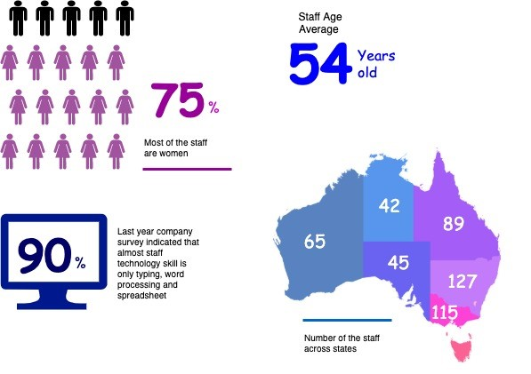

To help employees identify phishing emails, IT holds annual training to show them what red flags to look for. Then, IT sends mock phishing attacks to test them. If a user clicks on a couple simulated phishing emails, they’re required to take the security training again. Human nature being what it is, some users were ignoring legitimate email because they didn’t want to make a mistake that would require them to take the training again. Others decided to play it safe and send every questionable email they received to IT to see if it was OK. While IT recognized the obvious threats, even they had to question some of the attachments. “You can imagine the amount of time we spent investigating emails,” said Potter. “It took about an hour per email to copy the attachment to a USB drive and then spin up a machine to test the file off network,” he explained. “That’s valuable time that IT could spend doing other things.”

You are work as an IT project manager assigned by Potter to handle this problem in the company. The company decide to use the system to detect a Spear-Phishing. To accelerate suspicious email analysis and response, Heaven Systems implemented MailMon, an automated phishing incident reporting and response service that empowers end users to report suspicious emails directly from the inbox. MailMon runs on Microsoft Exchange 2013 or newer and Office365; it is deployed to end users as an Outlook plug-in, including Outlook App for Android and iOS devices.

You and your friend are 10 years’ experience staff in the company. After you evaluate the MailMon, it generates a report in the complex form, many of the staff including a current IT department are not familiar with the system. Potter approved on new project team recruitment, and HR organised 3 **new graduated** IT staffs joining your team. Potter would like your team to gain more awareness on this cyber security incidence.

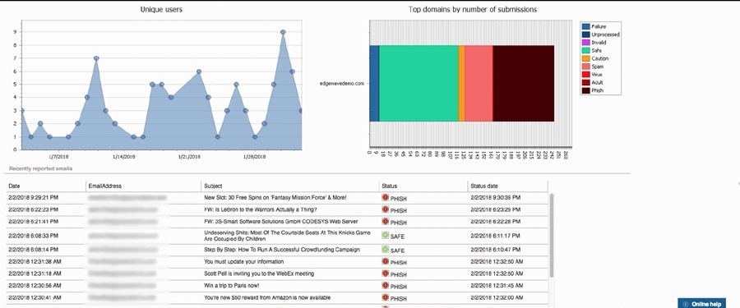

Figure: MailMon Monitoring Sample

# Heaven Systems internal IT Service Agreement

|  |  |  |
| --- | --- | --- |
| **Severity Level** | **Description** | **Target Response** |
| 1 (Outage) | Entire Company Server down | Immediately |
| 2 (Critical) | Entire Department Server down | Within 15 Minutes |
| 3 (Urgent) | Staff computer down | Within 1 hours |
| 4 (Important) | Staff computer not work properly or potential for interrupt their routine work | Within 3 hours |
| 5 (General) | Upgrade software  Training request | Within 48 hours |

# Task 1: Scope issue

Now, in the mid of November, you are required to prepare the report for the management team on company security awareness. The report should indicate:

1. The company current issue:

Heaven Systems was experiencing an increase of phishing emails that were reaching employee inboxes and introducing the risk of a data breach. As phishing attacks increased, productivity slowed down while end users waited for IT to investigate the suspicious emails.

**More ICT security issue attached in the end of this assessments (Reference)**:

The company face the increase of phishing emails, but staff not enough ability to handle.

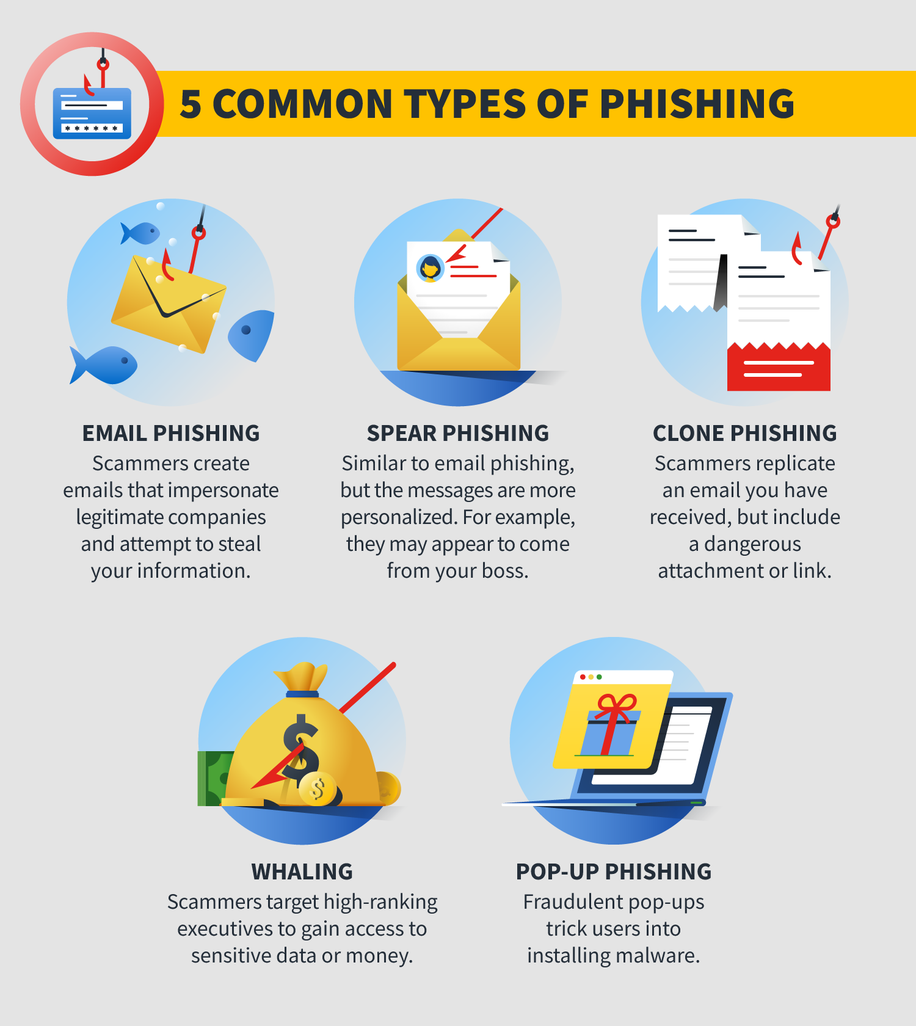

1. Brief for possible solution to identified issue. Each solution must be assessed on
   * commercial potential

Phishing is often targeted at commercial potential in order to gain access to sensitive information such as financial data, intellectual property, and customer information. Phishing emails are designed to appear as if they are coming from a legitimate source, such as a bank or a business, in order to trick the recipient into providing confidential information. This information can then be used for financial gain or to gain access to corporate networks. As such, businesses need to be aware of the risks posed by phishing and take steps to protect themselves from such attacks. This includes educating staff and implementing security measures such as two-factor authentication and email filtering.

* + suitability for the target audience or purpose

The target audience for this information is business owners and employees, as they are the most likely to be targeted by phishing scams. The purpose is to educate them on the risks posed by phishing and the steps they can take to protect themselves. This includes being aware of suspicious emails and links, using two-factor authentication, and implementing email filtering software. By educating their staff and taking the necessary security measures, businesses can protect themselves from falling victim to phishing scams.

* + feasibility of implementing solution

Implementing a solution to protect against phishing scams is feasible, however it may require an initial investment of money and time. This includes educating staff, implementing two-factor authentication, and using email filtering software. Additionally, organizations may need to invest in additional hardware or software, depending on the size and complexity of their network. However, this investment can be worth it in the long run, as it will help protect the organization from becoming a victim of phishing scams and the associated financial losses.

Refer: [Phishing - scam emails | Cyber.gov.au](https://www.cyber.gov.au/acsc/view-all-content/threats/phishing)

Phishing is a way that cybercriminals steal confidential information, such as online banking logins, credit card details, business login credentials or passwords/passphrases, by sending fraudulent messages (sometimes called ‘lures’).

## **Protect yourself from phishing attempts**

The best way to protect yourself from phishing attempts is to stay abreast of current threats, be cautious online and take steps to block malicious or unwanted messages from reaching you in the first place.

Take the following steps to protect yourself from phishing attempts:

* Don’t click on links in emails or messages, or open attachments, from people or organisations you don’t know.
* Be especially cautious if messages are very enticing or appealing (they seem too good to be true) or threaten you to make you take a suggested action.
* Before you click a link (in an email or on social media, instant messages, other web pages, or other means), hover over that link to see the actual web address it will take you to (usually shown at the bottom of the browser window). If you do not recognise or trust the address, try searching for relevant key terms in a web browser. This way you can find the article, video or web page without directly clicking on the suspicious link.
* If you're not sure, talk through the suspicious message with a friend or family member, or check its legitimacy by contacting the relevant business or organisation (using contact details sourced from the official company website).
* Use a spam filter to block deceptive messages from even reaching you.
* Understand that your financial institution and other large organisations (such as Amazon, Apple, Facebook, Google, PayPal and others) would never send you a link and ask you to enter your personal or financial details.
* Use safe behaviour online. Learn how to [use email safely](https://www.cyber.gov.au/node/1522) and [browse the web safely](https://www.cyber.gov.au/node/1520).
* Stay informed on the latest threats – sign up for the [ACSC Alert Service](https://www.cyber.gov.au/node/1601/). You can also find information about the latest scams on the Australian Government’s [Scamwatch website](https://www.scamwatch.gov.au/).
* Do not open any email if you do not clear where it came from.
* Take time to confirm the relevant company email or web site address.
* Call or email follow the office site info to confirm true or false.
* Never respond to emails or open attachments from unknown sources.
* Be suspicious of any emails that ask for personal information such as passwords or bank account information.
* Pay close attention to the URL of a website you visit. A legitimate website address should begin with “https”.
* Use two-factor authentication whenever possible.
* Be wary of emails that contain urgent or threatening language.

# Task 2: Selected solutions with Presentation

[ACSC - What is Phishing on Vimeo](https://vimeo.com/497805556)

1. Conduct a brainstorm on identified issue
2. Compare an idea solution for identified issue
3. Selected the solution and communicate to stakeholder (Your trainer)

a. **Prepare some (10-15) presentation slides** to present the following items to your trainer (All group members have to present equally)

* + Identified issue
  + Brainstorming evidence
  + Selected solution

1. Record feedback from your trainer and finalised the solution

# Presentation

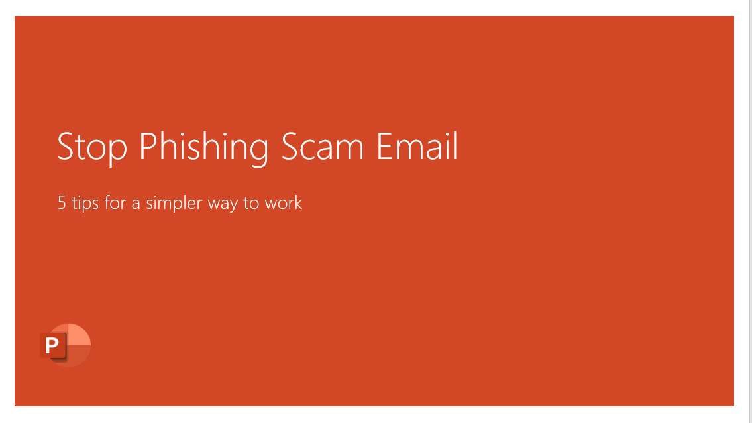

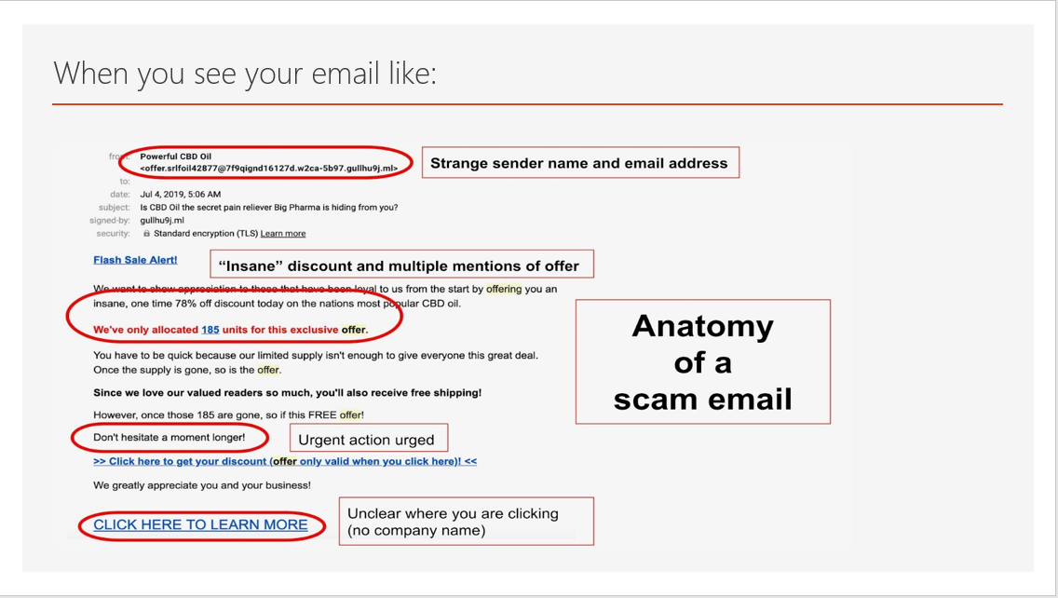

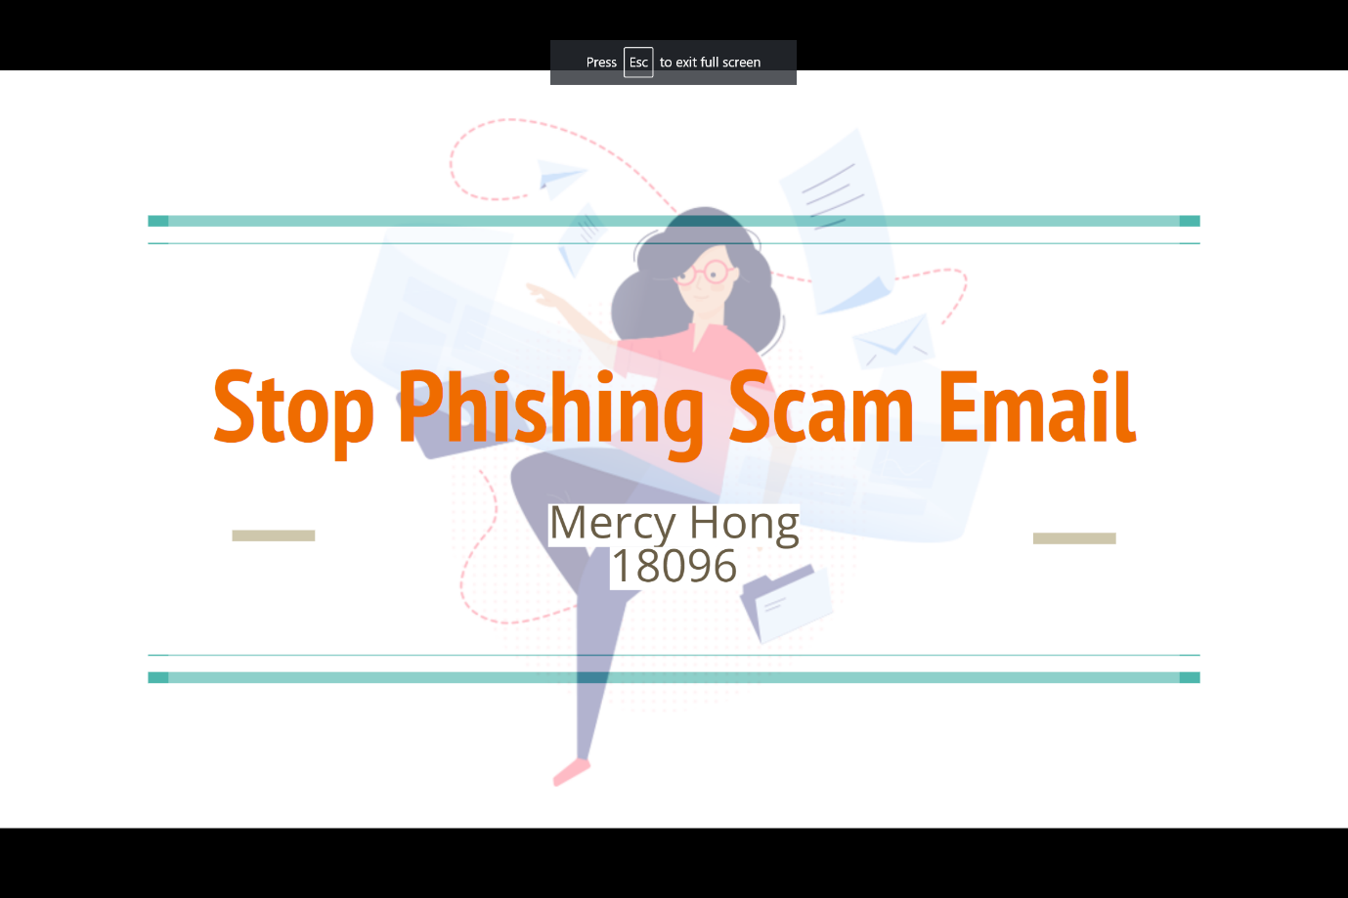

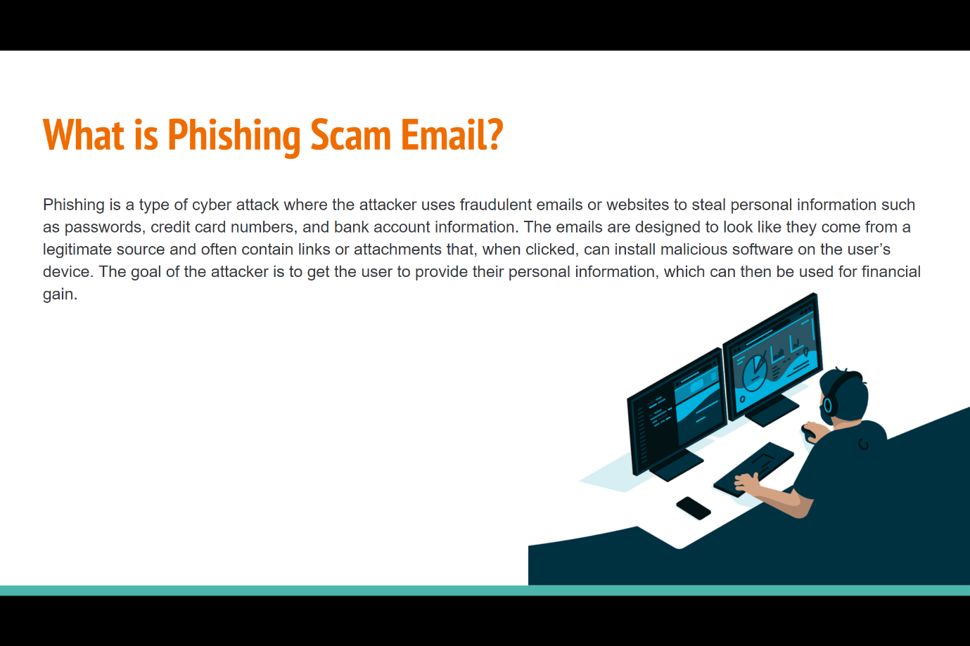

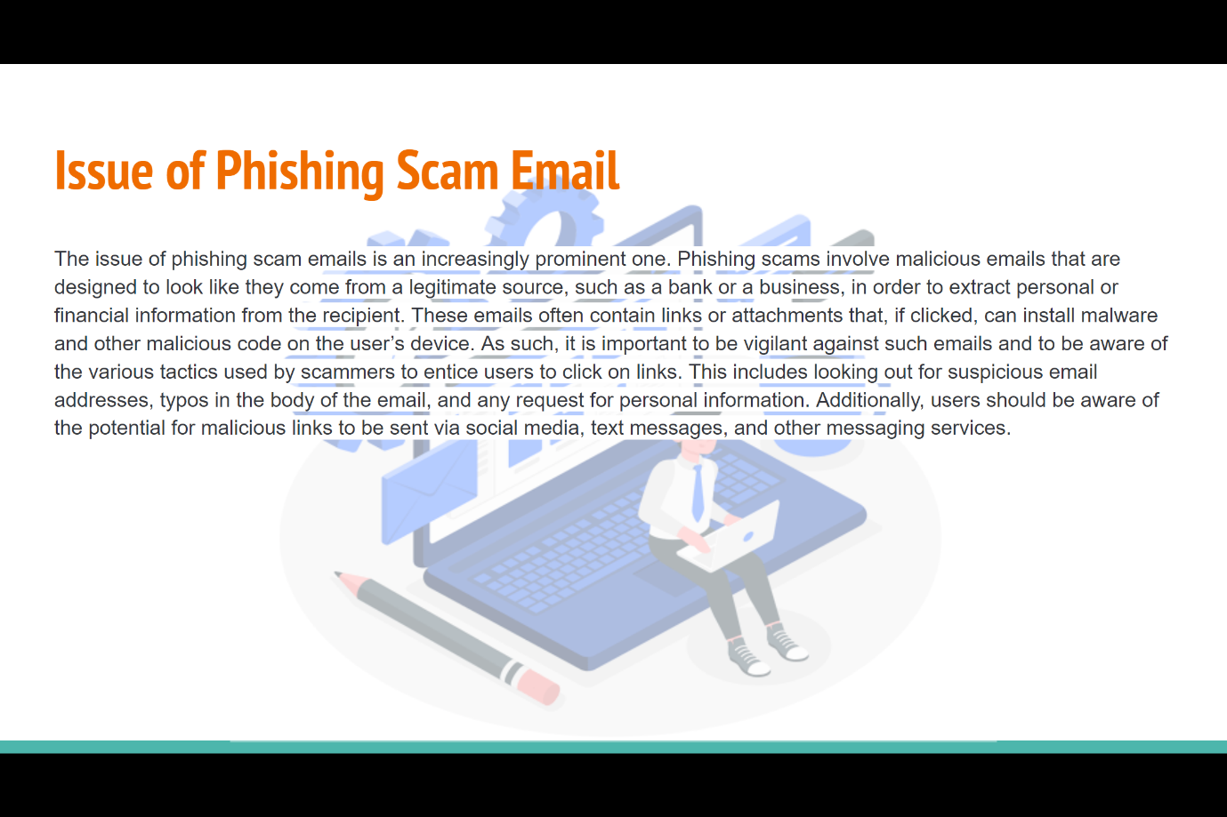

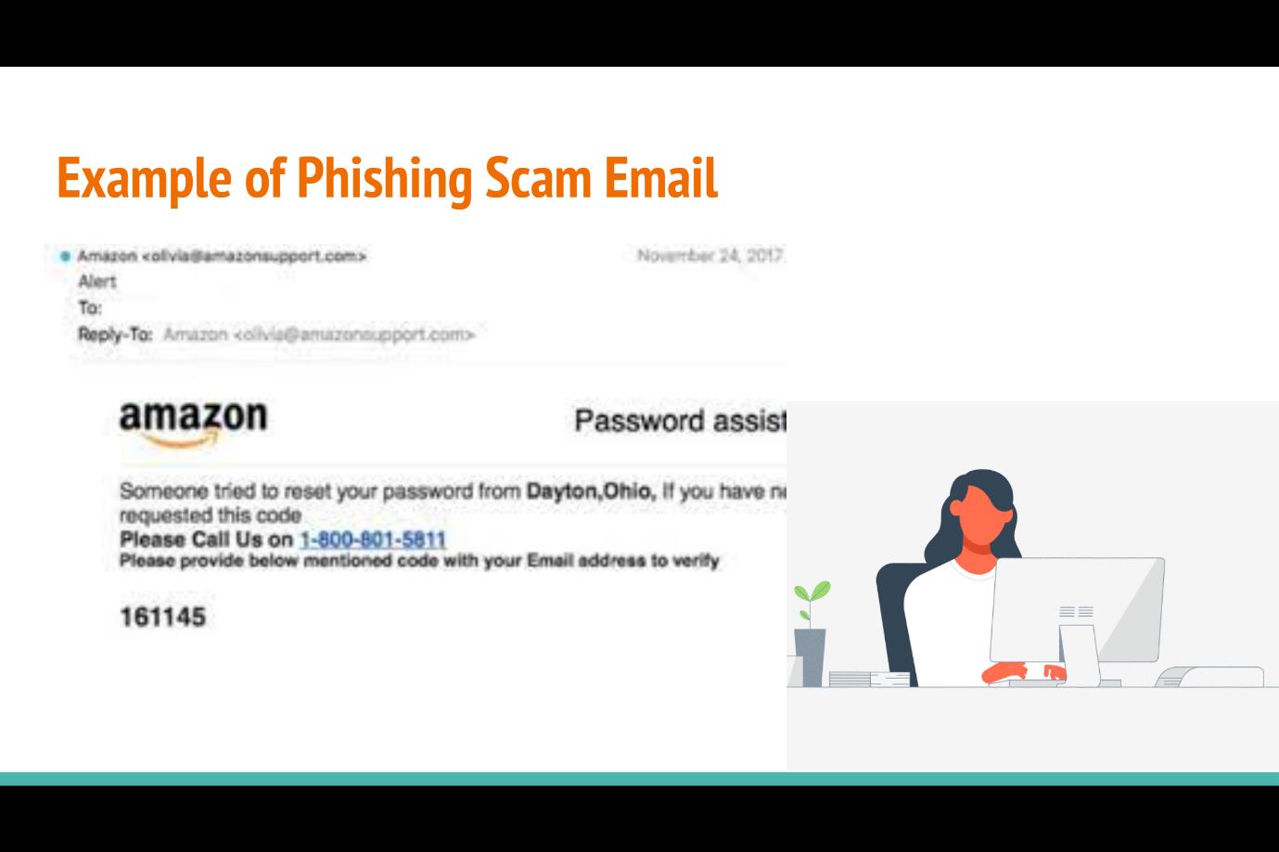

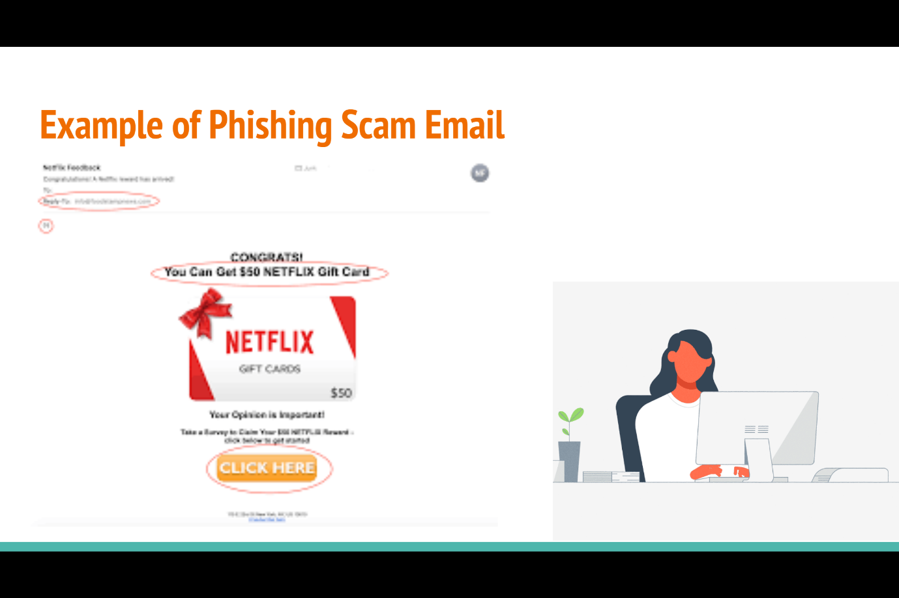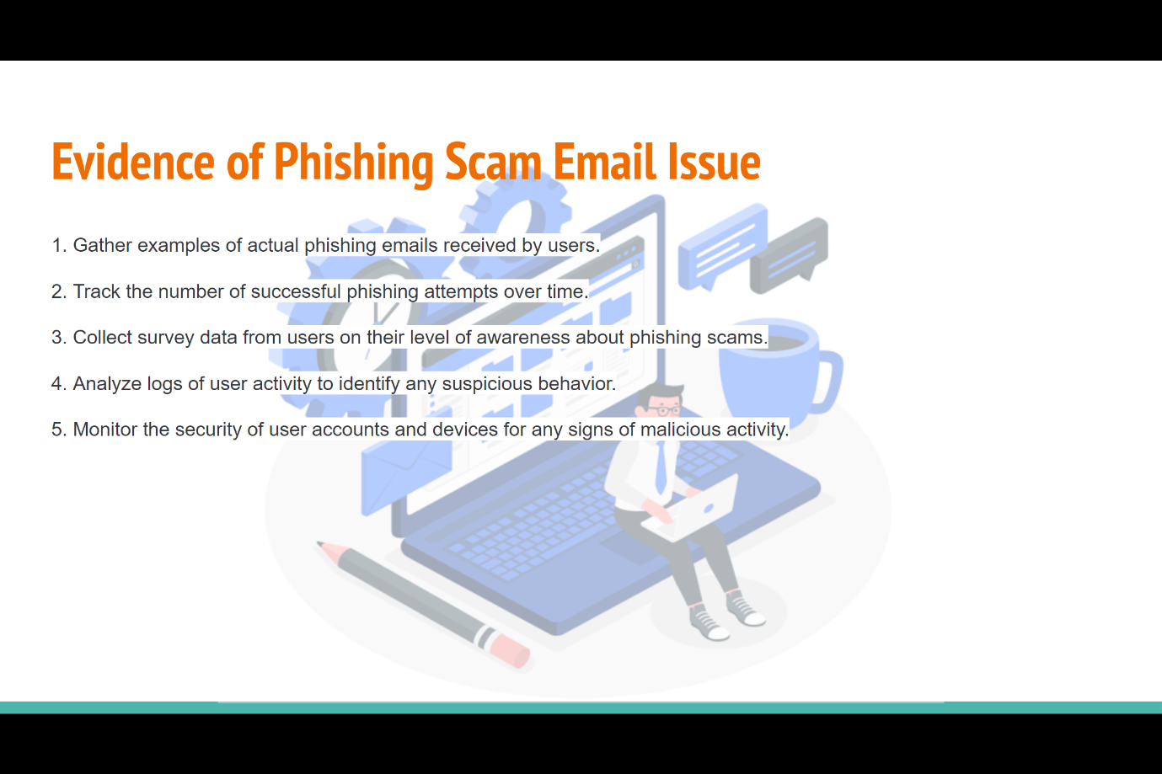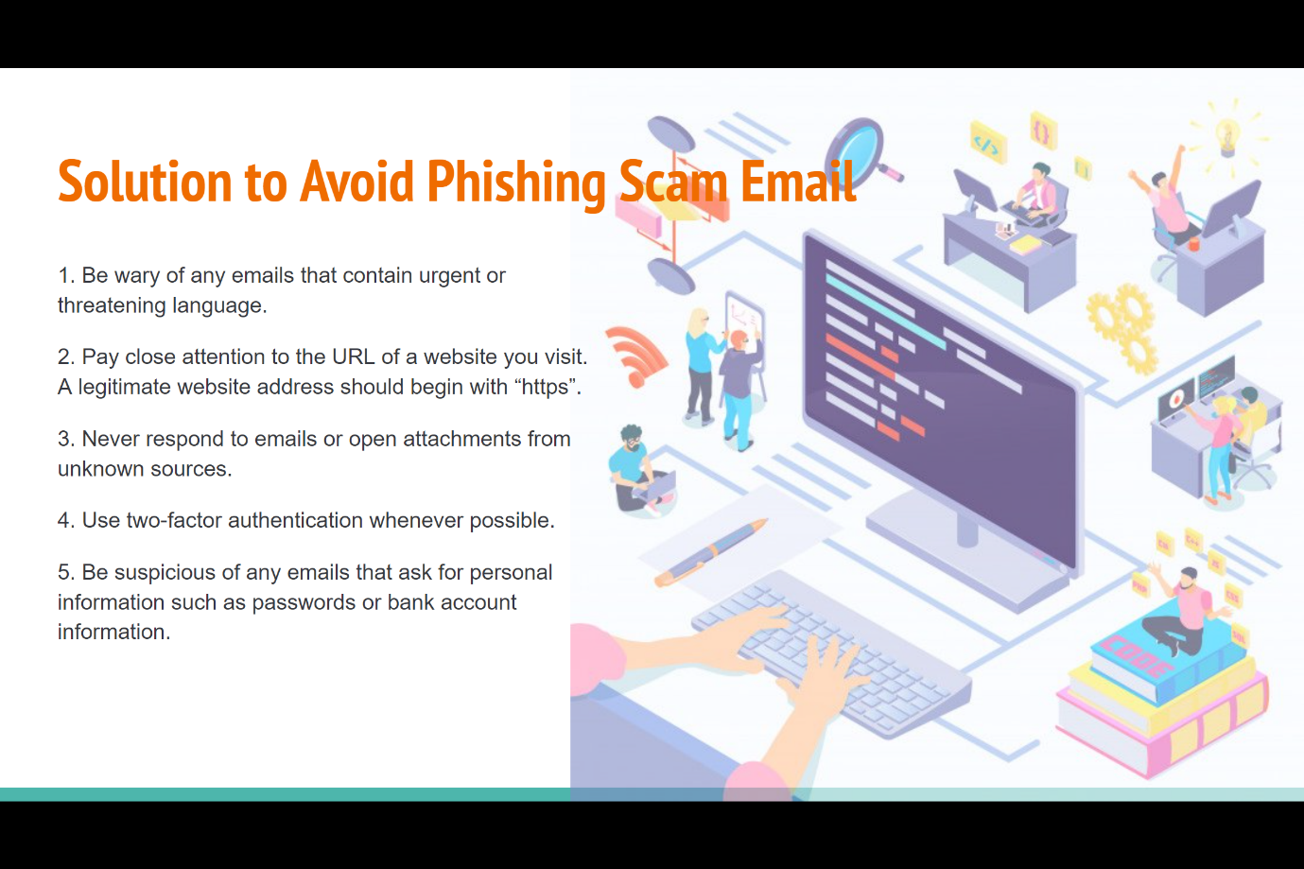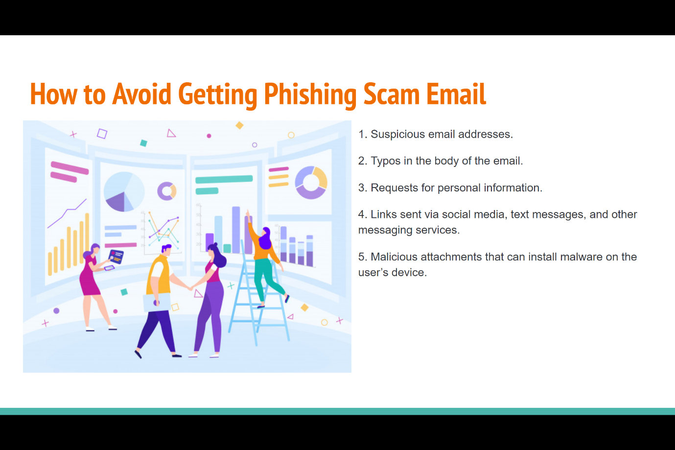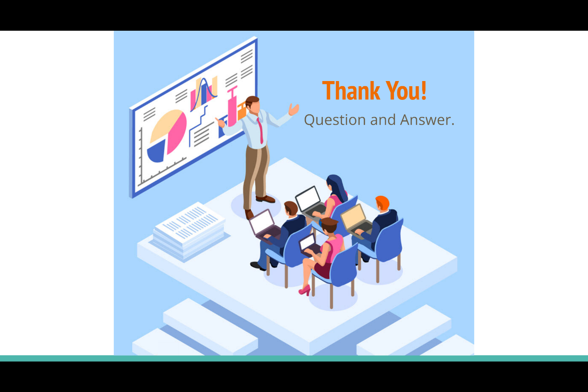

# **Search Index**

B

Brainstorming 6

C

cybercriminals 5

D

detect a Spear 3

H

Heaven Systems 4

I

idea solution 6

P

phishing attacks 2

phishing emails 2

# **REFERENCE:**

Please visit my site: [**https://mercyhong.github.io/DICTS180962023/**](https://mercyhong.github.io/DICTS180962023/)

See my case study about ICT security case

My database injection study

Communication safe example:

My computer work environment: